Austin Herb

United Mobile Homes

Rolling Hills Estates

Users Manual

**Table of Contents:**

Table of Contents Page 01

New User Registration Page 02

Logging In/Out Page 04

Basic Website Navigation Page 06

Contact Us Page 07

Community Events Page 10

Maintenance Requests Page 12

Admin Panel Page 14

Part 01: New User Registration

**Resident Keys:**

Before any account can be created (both user and administrator) a “resident key” is required. Each resident key is a unique, randomly generated string of 10 characters that incorporates both lowercase and uppercase as well as numbers. Each resident should receive only one key and keys should not be shared. Once a key has been used to create an account it cannot be used again.

**Creating New Accounts:**

Once the user receives their resident key, they can begin the account creation process by selecting the “Register” button located in the upper right-hand corner of the browser.

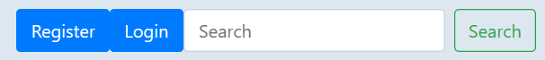

Figure [1]

Selecting the “Register” button will display the “user registration form” which requires the user to enter the following:

* First Name
* Last Name
* Email Address
* Telephone Number
* Account Password
* Resident Key

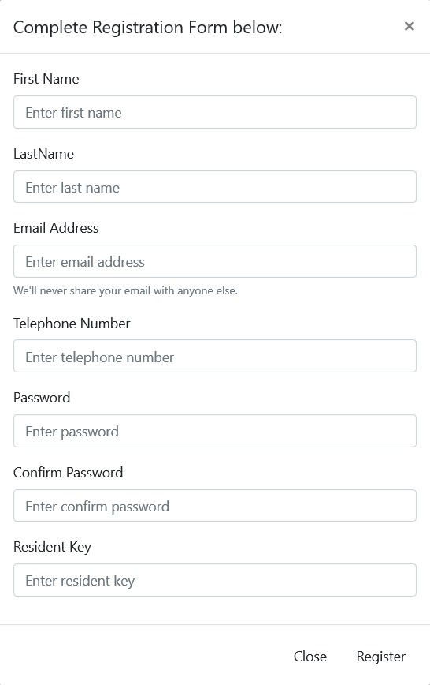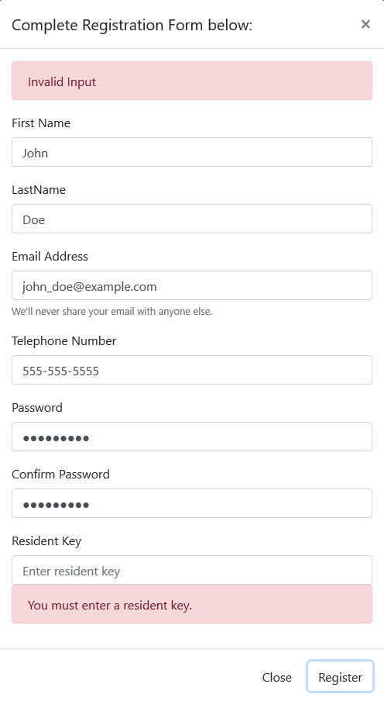

Figure [2] Figure [3]

Once the user registration form has been completed, select the “Register” button located at the bottom right-hand corner of the form. This will register the user and automatically log them in to their RHE account. Should any of these fields be left blank a warning will display under the field alerting the user to the missing information. A similar warning will display if the users input is invalid.

Part 02: Logging In/Out



Figure [4]

Users that already have an RHE account may log in by selecting the “Login” button located in the upper right-hand corner of the browser. Selecting this button will display the “Login Form”, this form requires the user to provide their email address and password before submitting.

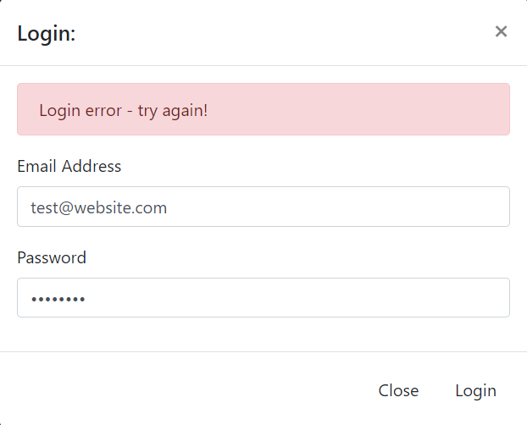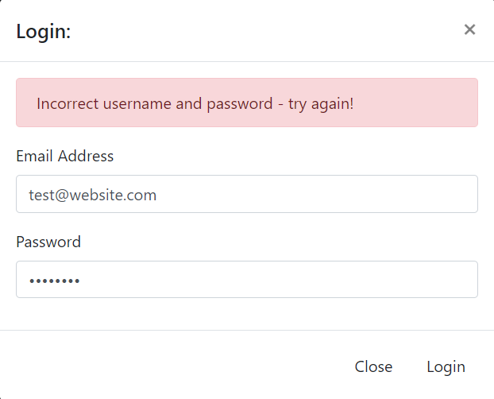

Figure [5] Figure [6]

Once the login form has been completed, the user may select the “Login” button located in the lower right-hand corner of the form to complete the login process. Should any of the fields be left blank a warning will display under the field alerting the user to the missing information. If an attempt is made to login with an account that does not exist, a “Login Error” will display at the top of the form. If the user attempts to login with the incorrect password an “Incorrect Password Error” will display at the top of the form.

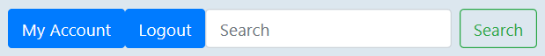

Figure [7]

Once the user has successfully logged in, the “Register” button will change to “My Account”. This button will display the “Edit Account Form”. This form allows users to edit any personal information that was submited during the registration process. The “Login” button will also change to a “Logout” button. Selecting this will log the user out and return them to the RHE home page.

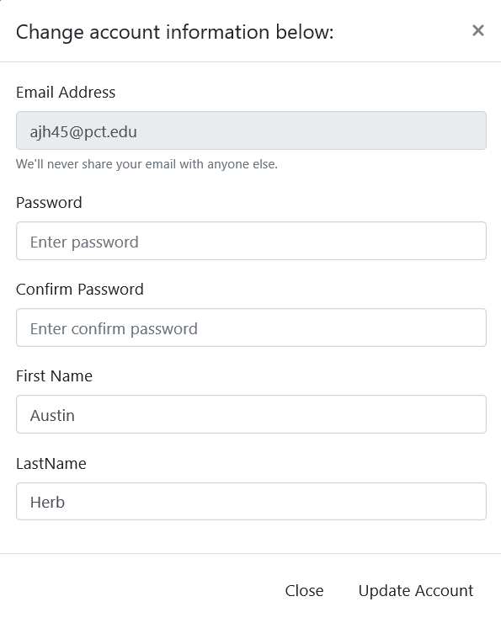

Once the necessary changes have been made, the user can select the “Update Account” button located in the bottom right-hand corner to save the changes to their account. Selecting the “Close” button will close the form and return the user to their previous page.

*Figure H[8]*

Part 03: Basic Website Navigation

The Rolling Hills Estates website can easily be navigated using the navigation bar located at the top of the browser. Users that have not logged in can use the navigation bar to access the following subdomains:

* Home
* About Us
* Properties
* Contact Us
* Community Events



Figure [9]

Users that have created an RHE account will have access to two additional subdomains called “Maintenance Requests” and “Rent Manager”. The maintenance requests subdomain allows users to submit requests for various forms of home maintenance. The Rent Manager subdomain redirects users to UMH’s Rent Manager system at https://umh.twa.rentmanager.com/



Figure [10]

If a user’s account is designated an administrative account, the navigation bar will include the “Admin Panel” subdomain as well as the “Maintenance Request” and “Rent Manager” subdomains when logged in. The admin panel allows the administrator to manage existing accounts, maintenance requests, and community events.



Figure [11]

Part 04: Contact Us

The “Contact Us” subdomain is located in the navigation bar at the top of the browser and can be accessed by anyone using the website. Selecting “Contact Us” will redirect the user to the “Contact Form” which requires the following information:

* First Name
* Last Name
* Email Address
* Telephone Number
* Street Address
* Questions/Comments

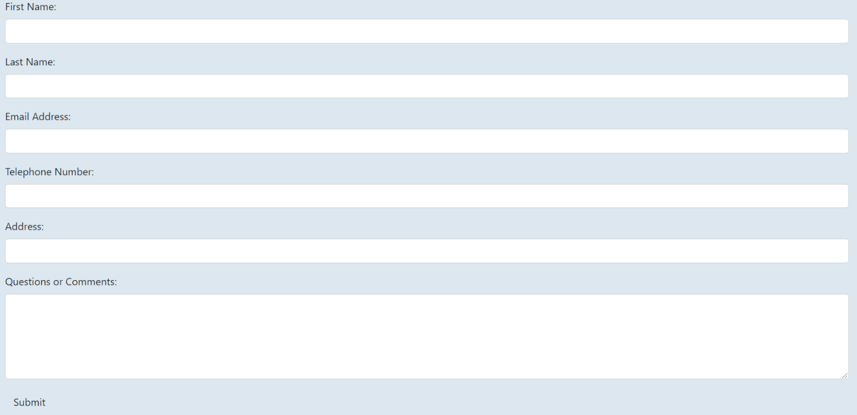

Figure [12]

If a user or an administrator has logged in, all of the required fields will be filled with that user’s information except for the address field and the questions/comments field.

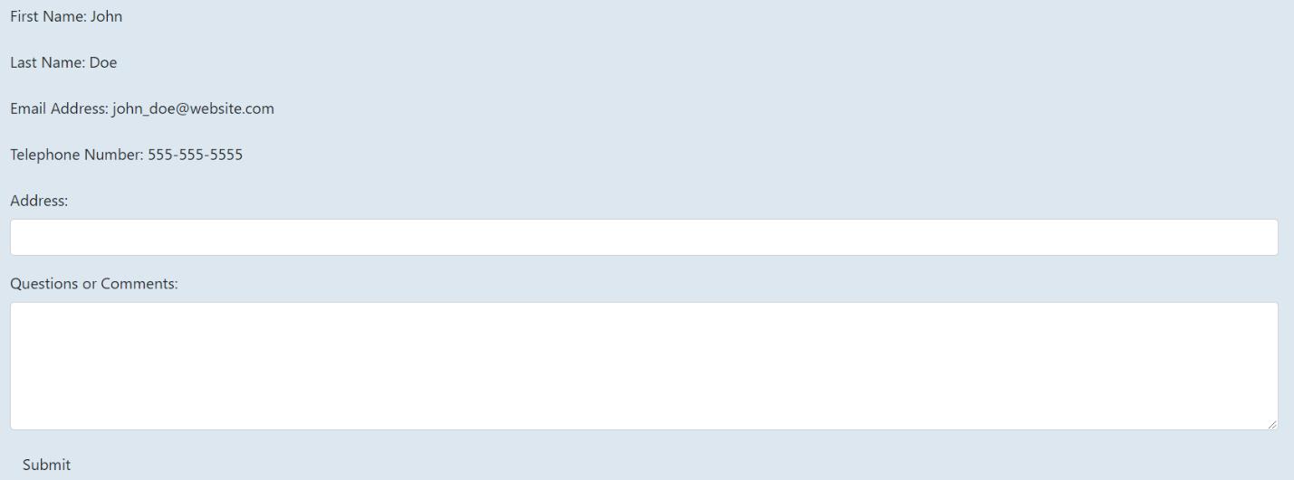

Figure [13]

Once all of the necessary fields have been completed, the user may select the “Submit” button located in the lower left-hand corner of the contact form to submit their form to a member of the Rolling Hills Estates customer support team. Should any errors exist with the submitted form, the user will be redirected to a subdomain that displays all of the errors. The user can then select “Go back” to return to the contact form to correct those errors.

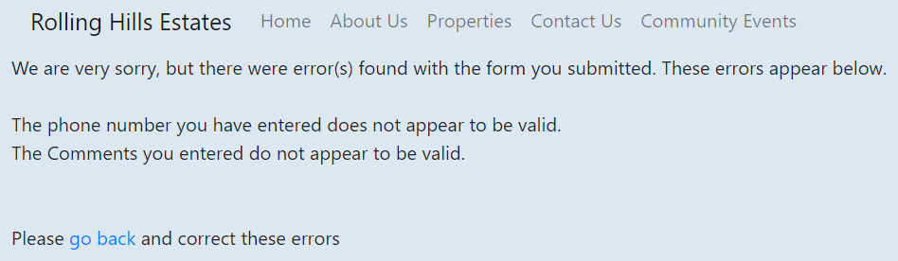

Figure [14]

If no errors exist within the form, the user will be redirected to a subdomain that informs them that their contact form was submitted successfully.

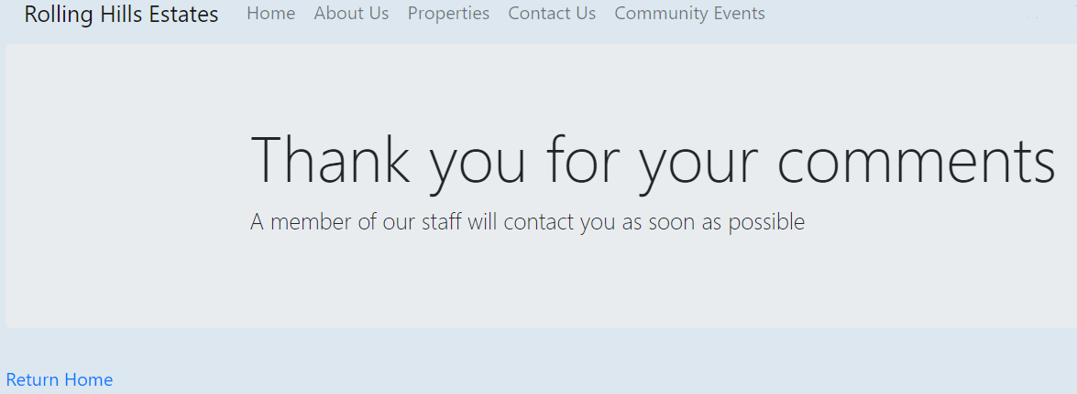

Figure [15]

Upon the successful submission of a contact form, a confirmation email and text message will be sent to the users submitted email and telephone number respectively.

Part 05: Community Events

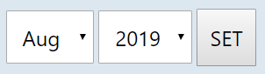

Figure P[16]

The “Community Events” subdomain is located in the navigation bar at the top of the browser and can be accessed by anyone using the website. Selecting “Community Events” will redirect the user to the community calendar. The month and year can be adjusted using the dropdown boxes located above the calendar.

Selecting the “Set” button will display the calendar for the selected month and year. Events that had been created that month will display on their respective day on the calendar.

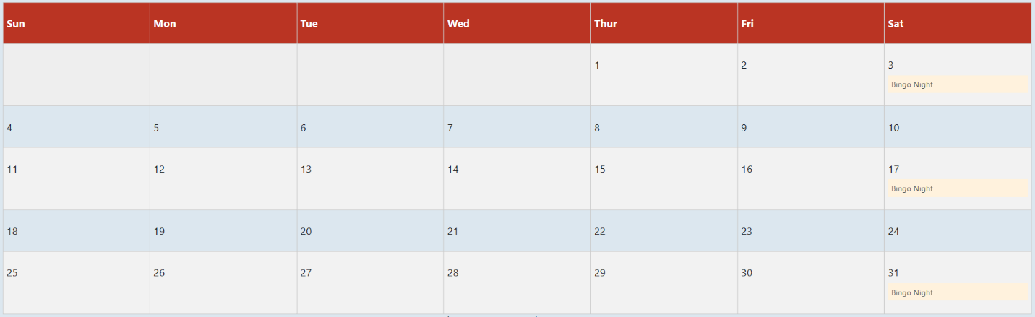

Figure Q[17]

New events can be added by double clicking a date on the events calendar, this will display the “Add Event” form below the calendar. The name of the event should be entered in the empty text field, the user may then save the event to the calendar by selecting the “Save” button located at the bottom of the form.

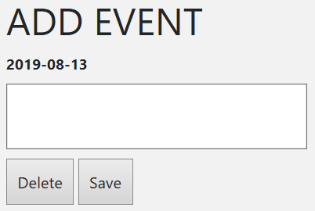

Figure R[18]

If an event has already been created on the selected date, the name of the event will automatically populate the text box when the form is opened. An existing event may be removed from the calendar by selecting the date and then selecting the “Delete” button located at the bottom of the form.

Part 06: Maintenance Requests

The “Maintenance Request” subdomain is located in the navigation bar at the top of the browser and can only be accessed once a user or administrator has logged in. Selecting “Maintenance Request” will redirect the user to the “Maintenance Request Form” which requires the following information:

* First Name
* Last Name
* Email Address
* Telephone Number
* Request Type
* Street Address
* Description of the Problem

If a user or an administrator has logged in, all the required fields will be filled with that user’s information except for the address field, the request type, and the description of the problem.

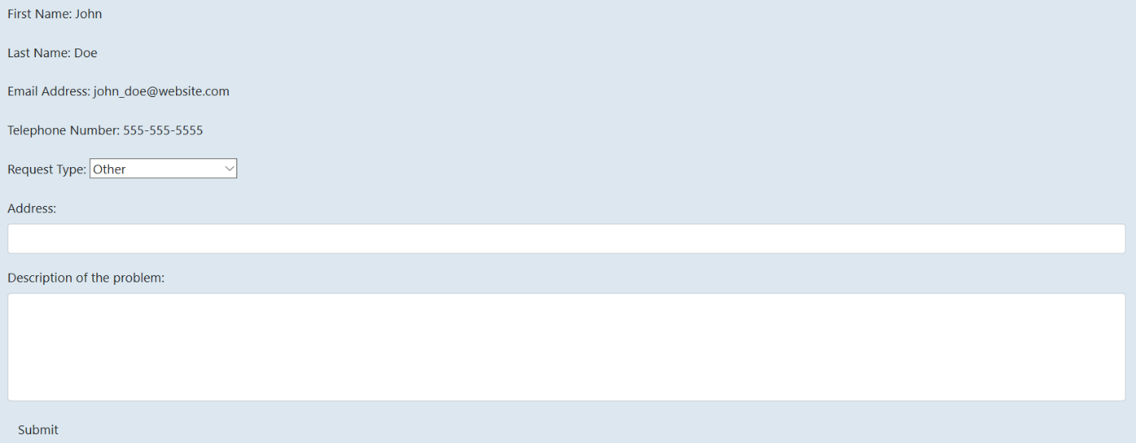

Figure [19]

Once all the necessary fields have been completed, the user may select the “Submit” button located in the lower left-hand corner of the maintenance request form to submit their form to a member of the Rolling Hills Estates maintenance team. Should any errors exist with the submitted form, the user will be redirected to a subdomain that displays all the errors. The user can then select “Go back” to return to the maintenance request form to correct those errors.

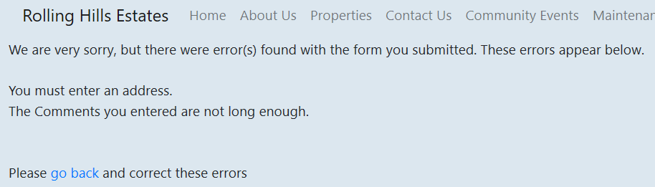

Figure [20]

If no errors exist within the form, the user will be redirected to a subdomain that informs them that their contact form was submitted successfully.

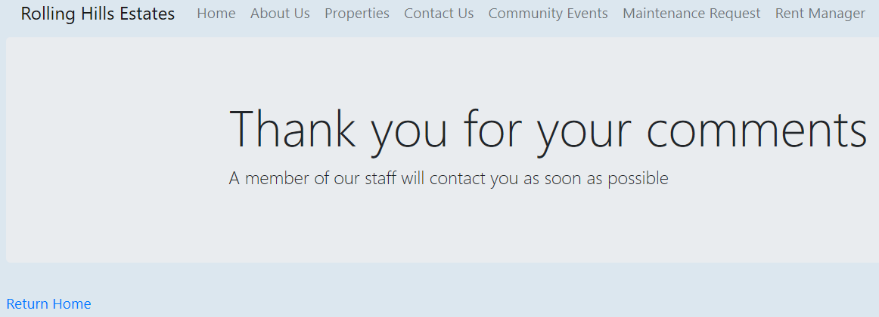

Figure [21]

Part 07: Admin Panel

The “Admin Panel” subdomain is located in the navigation bar at the top of the browser and can only be accessed by administrative users. Selecting “Admin Panel” will redirect the user to the administrators control panel.



Figure V[22]

The administrators control panel allows administrators to manage existing user accounts, submitted maintenance requests, and created community events. Existing user accounts will appear under the section labeled “Manage existing users:”.

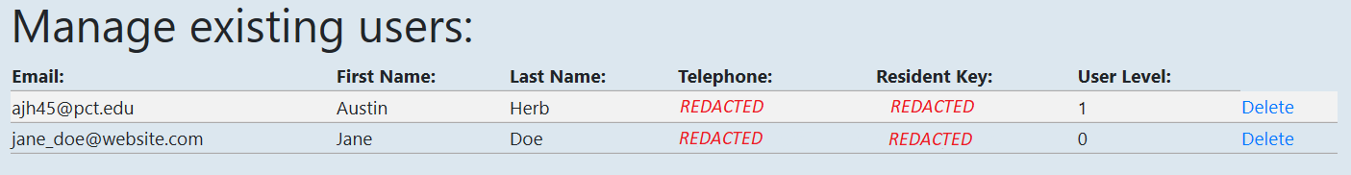

Figure W[23]

This table will display all the user accounts that have been created, including administrative accounts. The existing users table displays the users email address, first name, last name, telephone number, the resident key used during registration, and the users’ level.

There are two user levels, 0 and 1. An account with a user level of 1 is an administrative user. An account with a user level of 0 is a standard user.

Existing users can be removed by selecting the “Delete” button located on the right-hand side of the table.

Submitted maintenance requests will appear under the section labeled “Manage submitted maintenance requests:”.

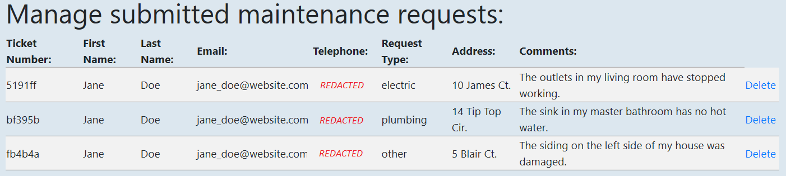

Figure X[24]

This table will display all the maintenance requests that have been submitted using the “Maintenance Request” subdomain. The submitted maintenance requests table displays the requests ticket number, the first name, last name, email address, telephone number, and address of the user that submitted the request as well as type of request and additional comments.

Submitted maintenance requests can be removed from the table by selecting the “Delete” button located on the right-hand side of the table.

1. New user registration button, existing user login button, and search bar.
2. Incomplete new user registration form.
3. New user registration form with existing errors.
4. New user registration button, existing user login button, and search bar.
5. Existing user login form with login error – account does not exist.
6. Existing user login form with login error – username and password do not match.
7. My Account button, Logout button, and search bar.
8. Incomplete form for updating account information.
9. Navigation bar from the point of view of a user that *has not* logged in.
10. Navigation bar from the point of view of a user that *has* logged in.
11. Navigation bar from the point of view of an administrative user that has logged in.
12. Contact form from the point of view of a user that *has not* logged in.
13. Contact form from the point of view of a user that *has* logged in.
14. Subdomain displaying the errors that exist within a submitted contact form.
15. A successful submission of a contact form.
16. Dropdown bars for selecting the month and year of the community events calendar.
17. Community events calendar for August 2019.
18. An empty “Add Event” form from the community events calendar.
19. Maintenance Request form from the point of view of a user that *has* logged in.
20. Subdomain displaying the errors that exist within a submitted maintenance request form.
21. A successful submission of a maintenance request form.
22. Navigation bar from the point of view of an administrative user that has logged in.
23. Manage existing users table inside the administrators control panel.
24. Manage submitted maintenance requests table inside the administrators control panel.